**Multi Threading**

**Agenda**

1. Introduction.
2. The ways to define instantiate and start a new Thread.
3. Getting and setting name of a Thread.
4. Thread priorities.
5. The methods to prevent(stop) Thread execution.
6. yield()
7. join()
8. sleep()
9. Synchronization.
10. Inter Thread communication.
11. Deadlock
12. Daemon Threads.

**Multitasking:** Executing several tasks simultaneously is the concept of multitasking. There are two types of multitasking’s.

1. **Process based multitasking.**
2. **Thread based multitasking.**

**Diagram:**

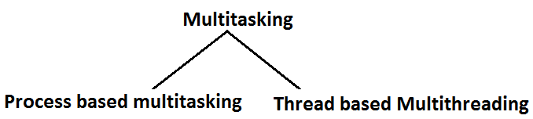

**Process based multitasking:** Executing several tasks simultaneously where each task is a separate independent process such type of multitasking is called process based multitasking.

**Example:**

* While typing a java program in the editor we can able to listen mp3 audio songs at the same time we can download a file from the net all these tasks are independent of each other and executing simultaneously and hence it is Process based multitasking.
* This type of multitasking is best suitable at “**os** **level**”.

**Thread based multitasking:** Executing several tasks simultaneously where each task is a separate independent part of the same program, is called Thread based multitasking. And each independent part is called a “Thread”.

* This type of multitasking is best suitable for “programatic level”.
* When compared with “C++”, developing multithreading examples is very easy in java because java provides in built support for multithreading through a rich API (Thread, Runnable, ThreadGroup, ThreadLocal….etc).
* In multithreading on 10% of the work the programmer is required to do and 90% of the work will be down by java API.
* The main important application areas of multithreading are:

1. To implement multimedia graphics.
2. To develop animations.
3. To develop video games etc.

* Whether it is process based or Thread based the main objective of multitasking is to improve performance of the system by reducing response time.

**The ways to define instantiate and start a new Thread:**

**What is singleton? Give example?**

* We can define a Thread in the following 2 ways.

1. By extending Thread class.
2. By implementing Runnable interface.

**Defining a Thread by extending “Thread class”:**

**Example:**

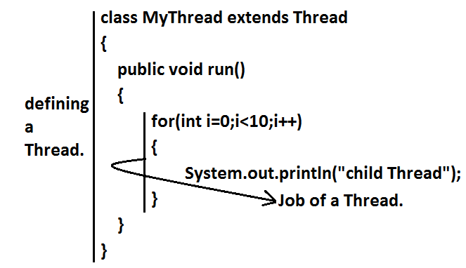

class ThreadDemo

{

public static void main(String[] args)

{

MyThread t=new MyThread();//Instantiation of a Thread

t.start();//starting of a Thread

for(int i=0;i<5;i++)

{

System.out.println("main thread");

}

}

}

**Case 1:** **Thread Scheduler:**

* If multiple Threads are waiting to execute then which Thread will execute 1st is decided by “Thread Scheduler” which is part of JVM.
* Which algorithm or behavior followed by Thread Scheduler we can’t expect exactly it is the JVM vendor dependent hence in multithreading examples we can’t expect exact execution order and exact output.
* The following are various possible outputs for the above program.

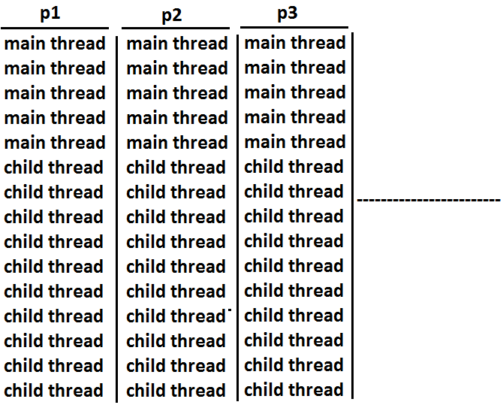

**Case 2:** **Difference between t.start() and t.run() methods.**

* In the case of t.start() a new Thread will be created which is responsible for the execution of run() method. But in the case of t.run() no new Thread will be created and run() method will be executed just like a normal method by the main Thread. In the above program if we are replacing t.start() with t.run() the following is the output.

**Output:**

child thread

child thread

child thread

child thread

child thread

child thread

child thread

child thread

child thread

child thread

main thread

main thread

main thread

main thread

main thread

* Entire output produced by only main Thread.

**Case 3:** **importance of Thread class start() method.**

* For every Thread the required mandatory activities like registering the Thread with Thread Scheduler will takes care by Thread class start() method and programmer is responsible just to define the job of the Thread inside run() method. That is start() method acts as best assistant to the programmer.

**Example:**

start()

{

1. Register Thread with Thread Scheduler

2. All other mandatory low level activities.

3. Invoke or calling run() method.

}

* We can conclude that without executing Thread class start() method there is no chance of starting a new Thread in java.

**Case 4:** **If we are not overriding run() method:**

* If we are not overriding run() method then Thread class run() method will be executed which has empty implementation and hence we won’t get any output.

**Example:**

class MyThread extends Thread

{}

class ThreadDemo

{

public static void main(String[] args)

{

MyThread t=new MyThread();

t.start();

}

}

* It is highly recommended to override run() method. Otherwise don’t go for multithreading concept.

**Case 5: Overriding of run() method.**

* We can overload run() method but Thread class start() method always invokes no argument run() method the other overload run() methods we have to call explicitly then only it will be executed just like normal method.

**Example:**

class MyThread extends Thread

{

public void run()

{

System.out.println("no arg method");

}

public void run(int i)

{

System.out.println("int arg method");

}

}

class ThreadDemo

{

public static void main(String[] args)

{

MyThread t=new MyThread();

t.start();

}

}

**Output:**

No arg method

**Case 6:**  **overriding of start() method:**

* If we override start() method then our start() method will be executed just like a normal method call and no new Thread will be started.

**Example:**

class MyThread extends Thread

{

public void start()

{

System.out.println("start method");

}

public void run()

{

System.out.println("run method");

}

}

class ThreadDemo

{

public static void main(String[] args)

{

MyThread t=new MyThread();

t.start();

System.out.println("main method");

}

}

**Output:**

start method

main method

* Entire output produced by only main Thread.

**Case 7:**

**Example 1:**

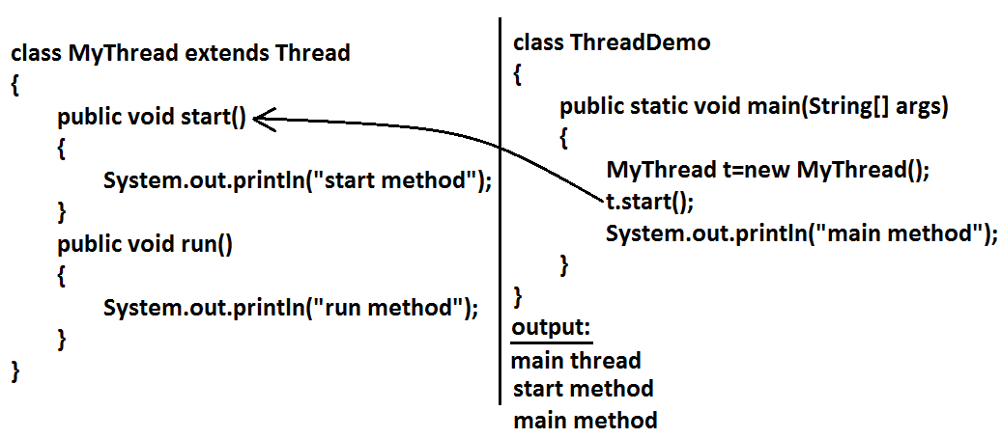

**Example 2:**

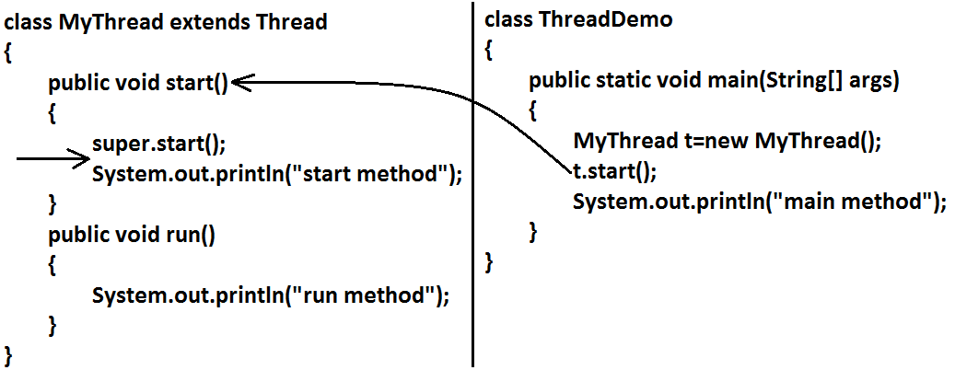

**Output:**

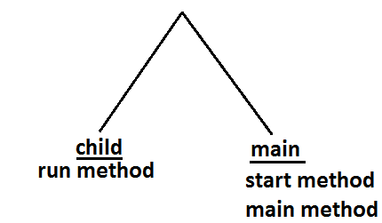

**Case 8:** **life cycle of the Thread:**

**Diagram:**

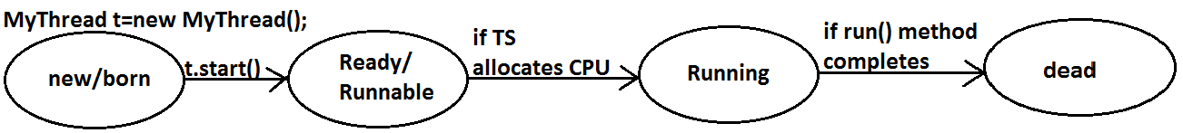

* Once we created a Thread object then the Thread is said to be in new state or born state.
* Once we call start() method then the Thread will be entered into Ready or Runnable state.
* If Thread Scheduler allocates CPU then the Thread will be entered into running state.
* Once run() method completes then the Thread will entered into dead state.

**Case 9:**

* After starting a Thread we are not allowed to restart the same Thread once again otherwise we will get runtime exception saying “IllegalThreadStateException”.

**Example:**

MyThread t=new MyThread();

t.start();//valid

;;;;;;;;

t.start();//we will get R.E saying: IllegalThreadStateException

**Defining a Thread by implementing Runnable interface:**

* We can define a Thread even by implementing Runnable interface also. Runnable interface present in java.lang.pkg and contains only one method run().

**Diagram:**

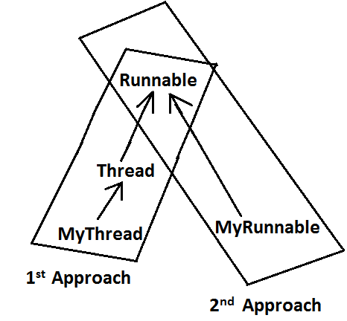

**Example:**

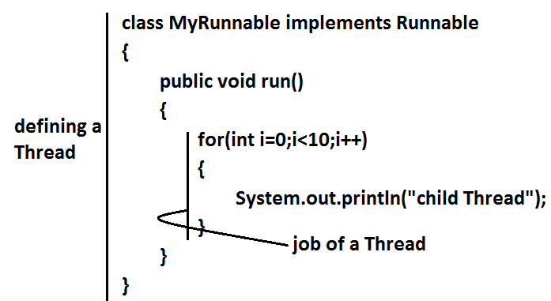

class ThreadDemo

{

public static void main(String[] args)

{

MyRunnable r=new MyRunnable();

Thread t=new Thread(r);//here r is a Target Runnable

t.start();

for(int i=0;i<10;i++)

{

System.out.println("main thread");

}

}

}

**Output:**

main thread

main thread

main thread

main thread

main thread

main thread

main thread

main thread

main thread

main thread

child Thread

child Thread

child Thread

child Thread

child Thread

child Thread

child Thread

child Thread

child Thread

child Thread

* We can’t expect exact output but there are several possible outputs.

**Case study:**

MyRunnable r=new MyRunnable();

Thread t1=new Thread();

Thread t2=new Thread(r);

**Case 1:** **t1.start():**

* A new Thread will be created which is responsible for the execution of Thread class run()method.

**Output:**

main thread

main thread

main thread

main thread

main thread

**Case 2:** **t1.run():**

* No new Thread will be created but Thread class run() method will be executed just like a normal method call.

**Output:**

main thread

main thread

main thread

main thread

main thread

**Case 3:** **t2.start():**

* New Thread will be created which is responsible for the execution of MyRunnable run() method.

**Output:**

main thread

main thread

main thread

main thread

main thread

child Thread

child Thread

child Thread

child Thread

child Thread

**Case 4:** **t2.run():**

* No new Thread will be created and MyRunnable run() method will be executed just like a normal method call.

**Output:**

child Thread

child Thread

child Thread

child Thread

child Thread

main thread

main thread

main thread

main thread

main thread

**Case 5:** **r.start():**

* We will get compile time error saying start()method is not available in MyRunnable class.

**Output:**

Compile time error

E:\SCJP>javac ThreadDemo.java

ThreadDemo.java:18

: cannot find symbol

Symbol: method start()

Location: class MyRunnable

**Case 6:** **r.run():**

* No new Thread will be created and MyRunnable class run() method will be executed just like a normal method call.

**Output:**

child Thread

child Thread

child Thread

child Thread

child Thread

main thread

main thread

main thread

main thread

main thread

**Best approach to define a Thread:**

* Among the 2 ways of defining a Thread, implements Runnable approach is always recommended.
* In the 1st approach our class should always extends Thread class there is no chance of extending any other class hence we are missing the benefits of inheritance.
* But in the 2nd approach while implementing Runnable interface we can extend some other class also. Hence implements Runnable mechanism is recommended to define a Thread.

**Thread class constructors:**

1. Thread t=new Thread();
2. Thread t=new Thread(Runnable r);
3. Thread t=new Thread(String name);
4. Thread t=new Thread(Runnable r,String name);
5. Thread t=new Thread(ThreadGroup g,String name);
6. Thread t=new Thread(ThreadGroup g,Runnable r);
7. Thread t=new Thread(ThreadGroup g,Runnable r,String name);
8. Thread t=new Thread(ThreadGroup g,Runnable r,String name,long stackSize);

**Durga’s approach to define a Thread(not recommended to use):**

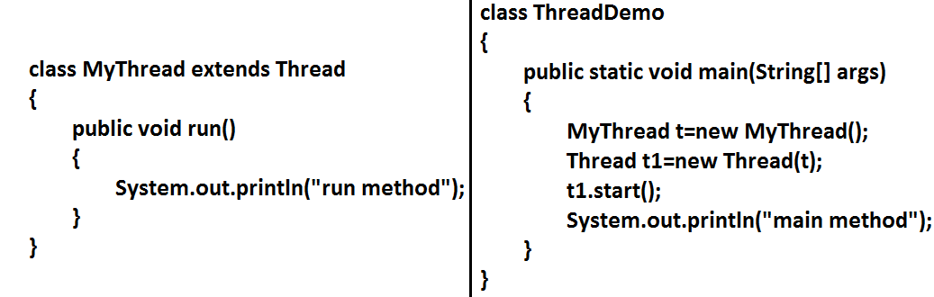

**Diagram:**

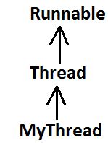

**Output:**

main method

run method

**Getting and setting name of a Thread:**

* Every Thread in java has some name it may be provided explicitly by the programmer or automatically generated by JVM.
* Thread class defines the following methods to get and set name of a Thread.

**Methods:**

1. **public final** **String** **getName()**
2. **public final void setName(****String****name)**

**Example:**

class MyThread extends Thread

{}

class ThreadDemo

{

public static void main(String[] args)

{

System.out.println(Thread.currentThread().getName());//main

MyThread t=new MyThread();

System.out.println(t.getName());//Thread-0

Thread.currentThread().setName("Bhaskar Thread");

System.out.println(Thread.currentThread().getName());//Bhaskar Thread

}

}

**Note:** We can get current executing Thread object reference by using Thread.currentThread() method.

**Thread Priorities**

* Every Thread in java has some priority it may be default priority generated by JVM (or) explicitly provided by the programmer.
* The valid range of Thread priorities is 1 to 10[but not 0 to 10] where 1 is the least priority and 10 is highest priority.
* Thread class defines the following constants to represent some standard priorities.

1. **Thread. MIN_PRIORITY----------1**
2. **Thread. MAX_PRIORITY----------10**
3. **Thread. NORM_PRIORITY--------5**

* There are no constants like Thread.LOW_PRIORITY, Thread.HIGH_PRIORITY
* Thread scheduler uses these priorities while allocating CPU.
* The Thread which is having highest priority will get chance for 1st execution.
* If 2 Threads having the same priority then we can’t expect exact execution order it depends on Thread scheduler whose behavior is vendor dependent.
* We can get and set the priority of a Thread by using the following methods.

1. **public final int getPriority()**
2. **public final void setPriority(int newPriority);//the allowed values are 1 to 10**

* The allowed values are 1 to 10 otherwise we will get runtime exception saying “IllegalArgumentException”.

**Default priority:**

* The default priority only for the main Thread is 5. But for all the remaining Threads the default priority will be inheriting from parent to child. That is whatever the priority parent has by default the same priority will be for the child also.

**Example 1:**

class MyThread extends Thread

{}

class ThreadPriorityDemo

{

public static void main(String[] args)

{

System.out.println(Thread.currentThread().getPriority());//5

Thread.currentThread().setPriority(9);

MyThread t=new MyThread();

System.out.println(t.getPriority());//9

}

}

**Example 2:**

class MyThread extends Thread

{

public void run()

{

for(int i=0;i<10;i++)

{

System.out.println("child thread");

}

}

}

class ThreadPriorityDemo

{

public static void main(String[] args)

{

MyThread t=new MyThread();

//t.setPriority(10); **1**

t.start();

for(int i=0;i<10;i++)

{

System.out.println("main thread");

}

}

}

* If we are commenting line 1 then both main and child Threads will have the same priority and hence we can’t expect exact execution order.
* If we are not commenting line 1 then child Thread has the priority 10 and main Thread has the priority 5 hence child Thread will get chance for execution and after completing child Thread main Thread will get the chance in this the output is:

**Output:**

child thread

child thread

child thread

child thread

child thread

child thread

child thread

child thread

child thread

child thread

main thread

main thread

main thread

main thread

main thread

main thread

main thread

main thread

main thread

main thread

* Some operating systems(like windowsXP) may not provide proper support for Thread priorities. We have to install separate bats provided by vendor to provide support for priorities.

**The Methods to Prevent a Thread from Execution:**

* We can prevent(stop) a Thread execution by using the following methods.

1. **yield();**
2. **join();**
3. **sleep();**

**yield():**

* yield() method causes “to pause current executing Thread for giving the chance of remaining waiting Threads of same priority”.
* If all waiting Threads have the low priority or if there is no waiting Threads then the same Thread will be continued its execution.
* If several waiting Threads with same priority available then we can’t expect exact which Thread will get chance for execution.
* The Thread which is yielded when it get chance once again for execution is depends on mercy of the Thread scheduler.
* public static native void **yield**();

**Diagram:**

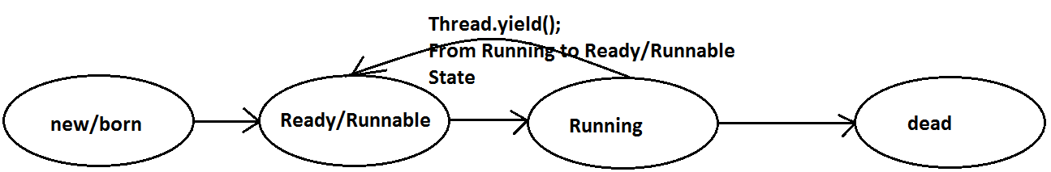

**Example:**

class MyThread extends Thread

{

public void run()

{

for(int i=0;i<5;i++)

{

Thread.yield();

System.out.println("child thread");

}

}

}

class ThreadYieldDemo

{

public static void main(String[] args)

{

MyThread t=new MyThread();

t.start();

for(int i=0;i<5;i++)

{

System.out.println("main thread");

}

}

}

**Output:**

main thread

main thread

main thread

main thread

main thread

child thread

child thread

child thread

child thread

child thread

* In the above example the chance of completing main Thread 1st is high because child Thread always calling yield() method.

**Join():**

* If a Thread wants to wait until completing some other Thread then we should go for join() method.

**Example:**

* If a Thread t1 executes t2.join() then t1 should go for waiting state until completing t2.

**Diagram:**

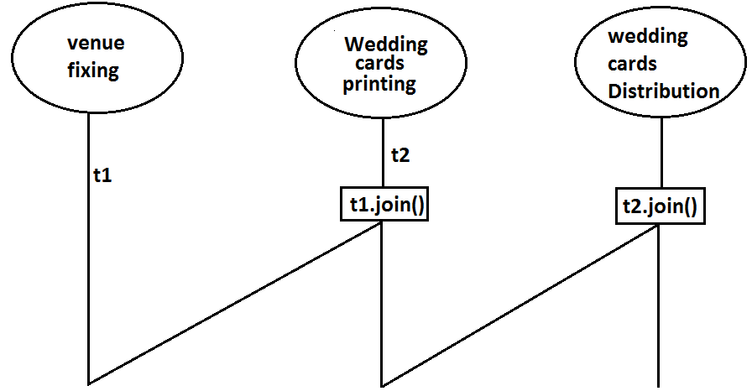

1. **public final void join()throws** **InterruptedException**
2. **public final void join(long ms) throws** **InterruptedException**
3. **public final void join(long ms,int ns) throws** **InterruptedException**

**Diagram:**

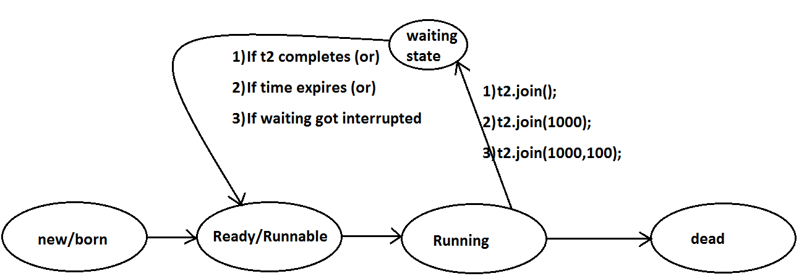

* Every join() method throws InterruptedException, which is checked exception hence compulsory we should handle either by try catch or by throws keyword.

**Example:**

class MyThread extends Thread

{

public void run()

{

for(int i=0;i<5;i++)

{

System.out.println("Seethe Thread");

try

{

Thread.sleep(2000);

}

catch (InterruptedException e){}

}

}

}

class ThreadJoinDemo

{

public static void main(String[] args)throws InterruptedException

{

MyThread t=new MyThread();

t.start();

//t.join(); **1**

for(int i=0;i<5;i++)

{

System.out.println("Rama Thread");

}

}

}

* If we are commenting line 1 then both Threads will be executed simultaneously and we can’t expect exact execution order.
* If we are not commenting line 1 then main Thread will wait until completing child Thread in this the output is seethe Thread 5 times followed by Rama Thread 5 times.

**Sleep() method:**

* If a Thread don’t want to perform any operation for a particular amount of time then we should go for sleep() method.

1. **public static native void sleep(long ms) throws** **InterruptedException**
2. **public static void sleep(long ms,int ns)throws** **InterruptedException**

**Diagram:**

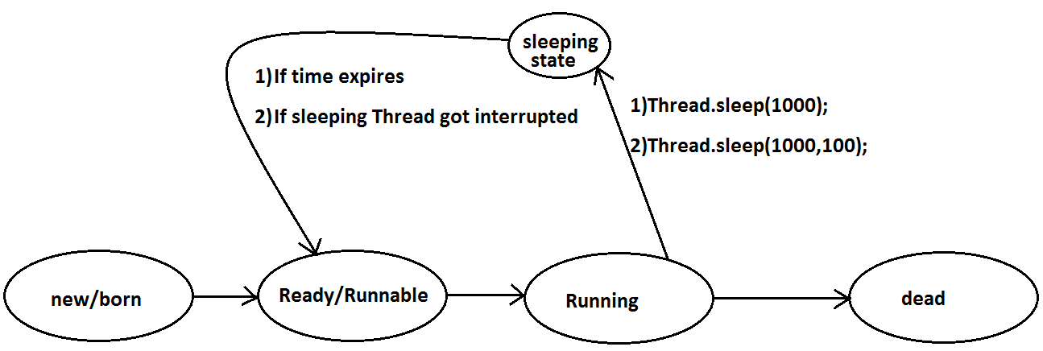

**Example:**

class ThreadJoinDemo

{

public static void main(String[] args)throws InterruptedException

{

System.out.println("M");

Thread.sleep(3000);

System.out.println("E");

Thread.sleep(3000);

System.out.println("G");

Thread.sleep(3000);

System.out.println("A");

}

}

**Output:**

M

E

G

A

**Interrupting a Thread:**

* We can interrupt a sleeping or waiting Thread by using interrupt()(break off) method of Thread class.

**Example:**

class MyThread extends Thread

{

public void run()

{

try

{

for(int i=0;i<5;i++)

{

System.out.println("i am lazy Thread :"+i);

Thread.sleep(2000);

}

}

catch (InterruptedException e)

{

System.out.println("i got interrupted");

}

}

}

class ThreadInterruptDemo

{

public static void main(String[] args)

{

MyThread t=new MyThread();

t.start();

//t.interrupt(); **1**

System.out.println("end of main thread");

}

}

* If we are commenting line 1 then main Thread won’t interrupt child Thread and hence child Thread will be continued until its completion.
* If we are not commenting line 1 then main Thread interrupts child Thread and hence child Thread won’t continued until its completion in this case the output is:

End of main thread

I am lazy Thread: 0

I got interrupted

**Note:**

* Whenever we are calling interrupt() method we may not see the effect immediately, if the target Thread is in sleeping or waiting state it will be interrupted immediately.
* If the target Thread is not in sleeping or waiting state then interrupt call will wait until target Thread will enter into sleeping or waiting state. Once target Thread entered into sleeping or waiting state it will effect immediately.
* In its lifetime if the target Thread never entered into sleeping or waiting state then there is no impact of interrupt call simply interrupt call will be wasted.

**Example:**

class MyThread extends Thread

{

public void run()

{

for(int i=0;i<5;i++)

{

System.out.println("iamlazy thread");

}

try

{

Thread.sleep(3000);

}

catch (InterruptedException e)

{

System.out.println("i got interrupted");

}

}

}

class ThreadInterruptDemo1

{

public static void main(String[] args)

{

MyThread t=new MyThread();

t.start();

t.interrupt();

System.out.println("end of main thread");

}

}

* In the above program interrupt() method call invoked by main Thread will wait until child Thread entered into sleeping state.
* Once child Thread entered into sleeping state then it will be interrupted immediately.

**Compression of yield, join and sleep() method?**

|  |  |  |  |
| --- | --- | --- | --- |
| **property** | **Yield()** | **Join()** | **Sleep()** |
| 1. **Purpose?** | To pause current executing Thread for giving the chance of remaining waiting Threads of same priority. | If a Thread wants to wait until completing some other Thread then we should go for join. | If a Thread don’t want to perform any operation for a particular amount of time then we should go for sleep() method. |
| 1. **Is it static?** | yes | no | yes |
| 1. **Is it final?** | no | yes | no |
| 1. **Is it overloaded?** | No | yes | yes |
| 1. **Is it throws** 2. **InterruptedException?** | no | yes | yes |
| 1. **Is it native method?** | yes | no | sleep(long ms)  sleep(long ms,int ns) |

**Synchronization**

* Synchronized is the keyword applicable for methods and blocks but not for classes and variables.
* If a method or block declared as the synchronized then at a time only one Thread is allow to execute that method or block on the given object.
* The main advantage of synchronized keyword is we can resolve date inconsistency problems.
* But the main disadvantage of synchronized keyword is it increases waiting time of the Thread and effects performance of the system.
* Hence if there is no specific requirement then never recommended to use synchronized keyword.
* Internally synchronization concept is implemented by using lock concept.
* Every object in java has a unique lock. Whenever we are using synchronized keyword then only lock concept will come into the picture.
* If a Thread wants to execute any synchronized method on the given object 1st it has to get the lock of that object. Once a Thread got the lock of that object then it’s allow to execute any synchronized method on that object. If the synchronized method execution completes then automatically Thread releases lock.
* While a Thread executing any synchronized method the remaining Threads are not allowed execute any synchronized method on that object simultaneously. But remaining Threads are allowed to execute any non-synchronized method simultaneously. [lock concept is implemented based on object but not based on method].

**Example:**

class Display

{

public synchronized void wish(String name)

{

for(int i=0;i<5;i++)

{

System.out.print("good morning:");

try

{

Thread.sleep(1000);

}

catch (InterruptedException e)

{}

System.out.println(name);

}

}

}

class MyThread extends Thread

{

Display d;

String name;

MyThread(Display d,String name)

{

this.d=d;

this.name=name;

}

public void run()

{

d.wish(name);

}

}

class SynchronizedDemo

{

public static void main(String[] args)

{

Display d1=new Display();

MyThread t1=new MyThread(d1,"dhoni");

MyThread t2=new MyThread(d1,"yuvaraj");

t1.start();

t2.start();

}

}

* If we are not declaring wish() method as synchronized then both Threads will be executed simultaneously and we will get irregular output.

**Output:**

good morning:good morning:yuvaraj

good morning:dhoni

good morning:yuvaraj

good morning:dhoni

good morning:yuvaraj

good morning:dhoni

good morning:yuvaraj

good morning:dhoni

good morning:yuvaraj

dhoni

* If we declare wish()method as synchronized then the Threads will be executed one by one that is until completing the 1st Thread the 2nd Thread will wait in this case we will get regular output which is nothing but

**Output:**

good morning:dhoni

good morning:dhoni

good morning:dhoni

good morning:dhoni

good morning:dhoni

good morning:yuvaraj

good morning:yuvaraj

good morning:yuvaraj

good morning:yuvaraj

good morning:yuvaraj

**Case study:**

**Case 1:**

Display d1=new Display();

Display d2=new Display();

MyThread t1=new MyThread(d1,"dhoni");

MyThread t2=new MyThread(d2,"yuvaraj");

t1.start();

t2.start();

**Diagram:**

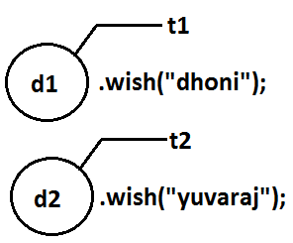

* Even though we declared wish() method as synchronized but we will get irregular output in this case, because both Threads are operating on different objects.

**Class level lock:**

* Every class in java has a unique lock. If a Thread wants to execute a static synchronized method then it required class level lock.
* Once a Thread got class level lock then it is allow to execute any static synchronized method of that class.
* While a Thread executing any static synchronized method the remaining Threads are not allow to execute any static synchronized method of that class simultaneously.
* But remaining Threads are allowed to execute normal synchronized methods, normal static methods, and normal instance methods simultaneously.
* Class level lock and object lock both are different and there is no relationship between these two.

**Synchronized block:**

* If very few lines of the code required synchronization then it’s never recommended to declare entire method as synchronized we have to enclose those few lines of the code with in synchronized block.
* The main advantage of synchronized block over synchronized method is it reduces waiting time of Thread and improves performance of the system.

**Example 1:** To get lock of current object we can declare synchronized block as follows.

**Synchronized(this){}**

**Example 2:** To get the lock of a particular object ‘b’ we have to declare a synchronized block as follows.

**Synchronized(b){}**

**Example 3:** To get class level lock we have to declare synchronized block as follows.

**Synchronized(Display.class){}**

* As the argument to the synchronized block we can pass either object reference or “.class file” and we can’t pass primitive values as argument [because lock concept is dependent only for objects and classes but not for primitives].

**Example:**

Int x=b;

Synchronized(x){}

**Output:**

Compile time error.

Unexpected type.

Found: int

Required: reference

**Questions:**

1. Explain about synchronized keyword and its advantages and disadvantages?
2. What is object lock and when a Thread required?
3. What is class level lock and when a Thread required?
4. What is the difference between object lock and class level lock?
5. While a Thread executing a synchronized method on the given object is the remaining Threads are allowed to execute other synchronized methods simultaneously on the same object?

**Ans:** No.

1. What is synchronized block and explain its declaration?
2. What is the advantage of synchronized block over synchronized method?
3. Is a Thread can hold more than one lock at a time?

**Ans:** Yes, up course from different objects.

**Example:**

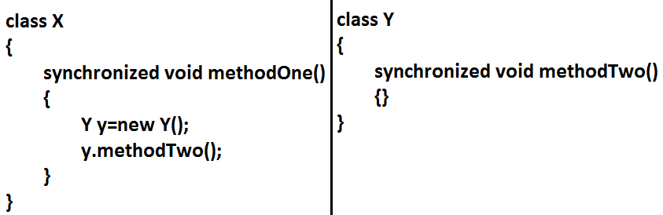

**Diagram:**

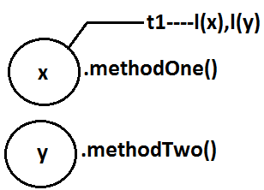

1. What is synchronized statement?

**Ans:** The statements which present inside synchronized method and synchronized block are called synchronized statements. [Interview people created terminology].

**Inter Thread communication (wait(),notify(), notifyAll()):**

* Two Threads can communicate with each other by using wait(), notify() and notifyAll() methods.
* The Thread which is excepting updation it has to call wait() method and the Thread which is performing updation it has to call notify() method. After getting notification the waiting Thread will get those updations.

**Diagram:**

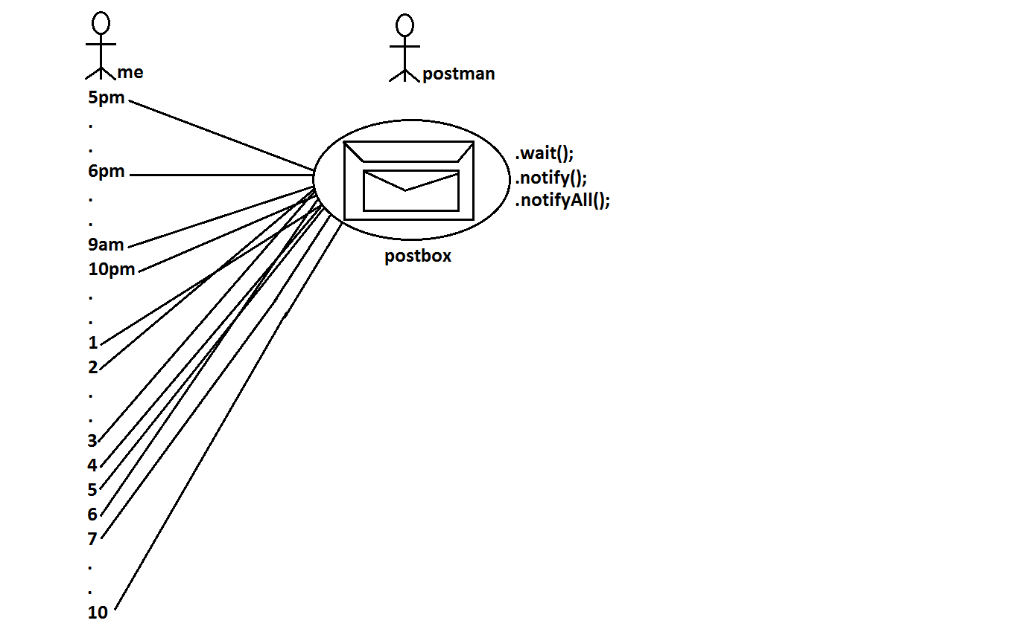

* wait(), notify() and notifyAll() methods are available in Object class but not in Thread class because Thread can call these methods on any common object.
* To call wait(), notify() and notifyAll() methods compulsory the current Thread should be owner of that object that is current Thread should has lock of that object that is current Thread should be in synchronized area. Hence we can call wait(), notify() and notifyAll() methods only from synchronized area otherwise we will get runtime exception saying IllegalMonitorStateException.
* Once a Thread calls wait() method on the given object 1st it releases the lock of that object immediately and entered into waiting state.
* Once a Thread calls notify() (or) notifyAll() methods it releases the lock of that object but may not immediately.
* Except these (wait(),notify(),notifyAll()) methods there is no other place(method) where the lock release will be happen.

|  |  |
| --- | --- |
| **Method** | **Is Thread Releases Lock?** |
| yield() | No |
| join() | No |
| sleep() | No |
| wait() | Yes |
| notify() | Yes |
| notifyAll() | Yes |

* Once a Thread calls wait(), notify(), notifyAll() methods on any object then it releases the lock of that particular object but not all locks it has.

1. **public final void wait()throws** **InterruptedException**
2. **public final native void wait(long ms)throws** **InterruptedException**
3. **public final void wait(long ms,int ns)throws** **InterruptedException**
4. **public final native void notify()**
5. **public final void notifyAll()**

**Diagram:**

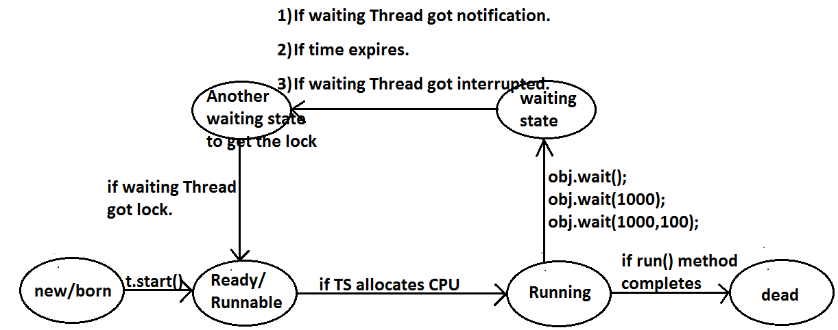

**Example 1:**

class ThreadA

{

public static void main(String[] args)throws InterruptedException

{

ThreadB b=new ThreadB();

b.start();

synchronized(b)

{

System.out.println("main Thread calling wait() method");//step-1

b.wait();

System.out.println("main Thread got notification call");//step-4

System.out.println(b.total);

}

}

}

class ThreadB extends Thread

{

int total=0;

public void run()

{

synchronized(this)

{

System.out.println("child thread starts calcuation");//step-2

for(int i=0;i<=100;i++)

{

total=total+i;

}

System.out.println("child thread giving notification call");//step-3

this.notify();

}

}

}

**Output:**

main Thread calling wait() method

child thread starts calculation

child thread giving notification call

main Thread got notification call

5050

**Example 2:**

**Producer consumer problem:**

* Producer(producer Thread) will produce the items to the queue and consumer(consumer thread) will consume the items from the queue. If the queue is empty then consumer has to call wait() method on the queue object then it will entered into waiting state.
* After producing the items producer Thread call notify() method on the queue to give notification so that consumer Thread will get that notification and consume items.

**Diagram:**

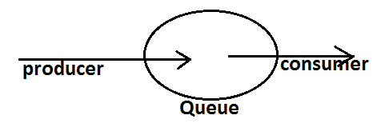

**Example:**

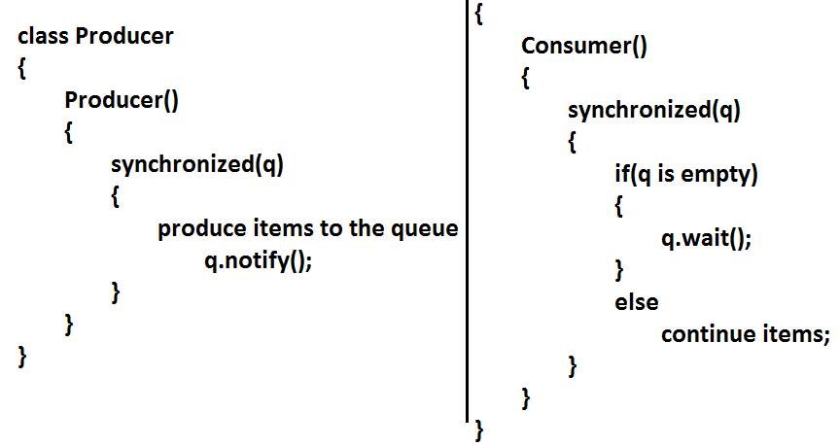

**Notify vs notifyAll():**

* We can use notify() method to give notification for only one Thread. If multiple Threads are waiting then only one Thread will get the chance and remaining Threads has to wait for further notification. But which Thread will be notify(inform) we can’t expect exactly it depends on JVM.
* We can use notifyAll() method to give the notification for all waiting Threads. All waiting Threads will be notified and will be executed one by one.

**Note:** On which object we are calling wait(), notify() and notifyAll() methods that corresponding object lock we have to get but not other object locks.

**Example:**

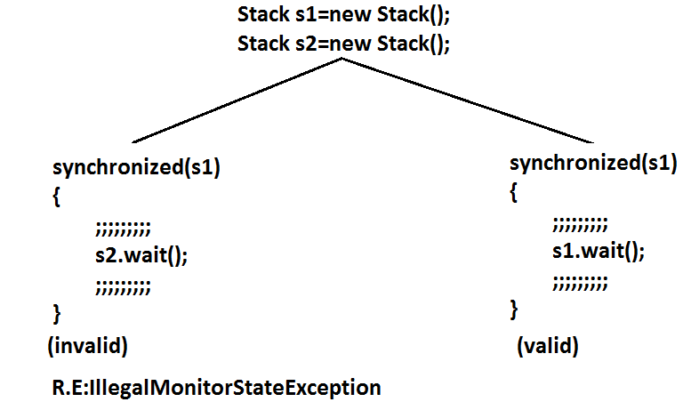

**Dead lock:**

* If 2 Threads are waiting for each other forever(without end) such type of situation(infinite waiting) is called dead lock.
* There are no resolution techniques for dead lock but several prevention(avoidance) techniques are possible.
* Synchronized keyword is the cause for deadlock hence whenever we are using synchronized keyword we have to take special care.

**Example:**

class A

{

public synchronized void foo(B b)

{

System.out.println("Thread1 starts execution of foo() method");

try

{

Thread.sleep(2000);

}

catch (InterruptedException e)

{}

System.out.println("Thread1 trying to call b.last()");

b.last();

}

public synchronized void last()

{

System.out.println("inside A, this is last()method");

}

}

class B

{

public synchronized void bar(A a)

{

System.out.println("Thread2 starts execution of bar() method");

try

{

Thread.sleep(2000);

}

catch (InterruptedException e)

{}

System.out.println("Thread2 trying to call a.last()");

a.last();

}

public synchronized void last()

{

System.out.println("inside B, this is last() method");

}

}

class DeadLock implements Runnable

{

A a=new A();

B b=new B();

DeadLock()

{

Thread t=new Thread(this);

t.start();

a.foo(b);//main thread

}

public void run()

{

b.bar(a);//child thread

}

public static void main(String[] args)

{

new DeadLock();//main thread

}

}

**Output:**

Thread1 starts execution of foo() method

Thread2 starts execution of bar() method

Thread2 trying to call a.last()

Thread1 trying to call b.last()

//here cursor always waiting.

**Daemon Threads:**

* The Threads which are executing in the background are called daemon Threads. The main objective of daemon Threads is to provide support for non daemon Threads.

**Example:**

Garbage collector

* We can check whether the Thread is daemon or not by using isDaemon() method.

**public final boolean isDaemon();**

* We can change daemon nature of a Thread by using setDaemon () method.

**public final void setDaemon(boolean b);**

## But we can change daemon nature before starting Thread only. That is after starting the Thread if we are trying to change the daemon nature we will get R.E saying IllegalThreadStateException.

* Main Thread is always non daemon and we can’t change its daemon nature because it’s already started at the beginning only.
* Main Thread is always non daemon and for the remaining Threads daemon nature will be inheriting from parent to child that is if the parent is daemon child is also daemon and if the parent is non daemon then child is also non daemon.
* Whenever the last non daemon Thread terminates automatically all daemon Threads will be terminated.

**Example:**

class MyThread extends Thread

{

public void run()

{

for(int i=0;i<10;i++)

{

System.out.println("lazy thread");

try

{

Thread.sleep(2000);

}

catch (InterruptedException e)

{}

}

}

}

class DaemonThreadDemo

{

public static void main(String[] args)

{

MyThread t=new MyThread();

t.setDaemon(true); **1**

t.start();

System.out.println("end of main Thread");

}

}

**Output:**

End of main Thread

Lazy thread

* If we are commenting line 1 then both main and child Threads are non daemon and hence both will be executed until they completion.
* If we are not commenting line 1 then main Thread is non daemon and child Thread is daemon and hence whenever main Thread terminates automatically child Thread will be terminated.

**Deadlock vs Starvation:**

* A long waiting of a Thread which never ends is called deadlock.
* A long waiting of a Thread which ends at certain point is called starvation.
* A low priority Thread has to wait until completing all high priority Threads.
* This long waiting of Thread which ends at certain point is called starvation.

**How to kill a Thread in the middle of the line?**

* We can call stop() method to stop a Thread in the middle then it will be entered into dead state immediately.

**public final void stop();**

* stop() method has been deprecated and hence not recommended to use.

**suspend and resume methods:**

* A Thread can suspend another Thread by using suspend() method then that Thread will be paused temporarily.
* A Thread can resume a suspended Thread by using resume() method then suspended Thread will continue its execution.

1. **public final void suspend();**
2. **public final void resume();**

* Both methods are deprecated and not recommended to use.

**RACE condition:**

* Executing multiple Threads simultaneously and causing data inconsistency problems is nothing but Race condition we can resolve race condition by using synchronized keyword.

**Life cycle of a Thread:**

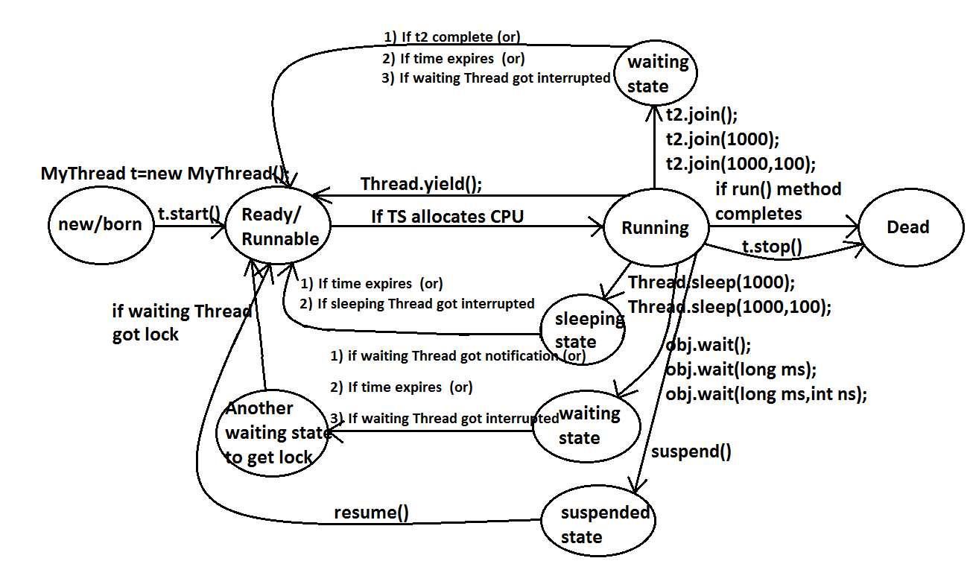

**What is the difference between extends Thread and implements Runnable?**

* Extends Thread is useful to override the public void run() method of Thread class.
* Implements Runnable is useful to implement public void run() method of Runnable interface.

**Extends Thread, implements Runnable which one is advantage?**

* If we extend Thread class, there is no scope to extend another class.

**Example:**

**Class MyClass extends Frame,Thread//invalid**

* If we write implements Runnable still there is a scope to extend one more class.

**Example:**

1. **class MyClass extends Thread implements Runnable**
2. **class MyClass extends Frame implements Runnable**

**How can you stop a Thread which is running?**

**Step 1:**

* Declare a boolean type variable and store false in that variable.

**boolean stop=false;**

**Step 2:**

* If the variable becomes true return from the run() method.

**If(stop) return;**

**Step 3:**

* Whenever to stop the Thread store true into the variable.

**System.in.read();//press enter**

**Obj.stop=true;**

**Questions:**

1. **What is a Thread?**
2. **Which Thread by default runs in every java program?**

* Ans: By default main Thread runs in every java program.

1. **What is the default priority of the Thread?**
2. **How can you change the priority number of the Thread?**
3. **Which method is executed by any Thread?**

* Ans: A Thread executes only public void run() method.

1. **How can you stop a Thread which is running?**
2. **Explain the two types of multitasking?**
3. **What is the difference between a process and a Thread?**
4. **What is Thread scheduler?**
5. **Explain the synchronization of Threads?**
6. **What is the difference between synchronized block and synchronized keyword?**
7. **What is Thread deadlock? How can you resolve deadlock situation?**
8. **Which methods are used in Thread communication?**
9. **What is the difference between notify() and notifyAll() methods?**
10. **What is the difference between sleep() and wait() methods?**
11. **Explain the life cycle of a Thread?**
12. **What is daemon Thread?**